***College logo College Logo whitecode logo***

***Saraswati Mandir Night College of commerce and Arts, Pune***

***And***

***SMDMM College***

***Organized national webinar***

***on***

***“Human Rights, A Gender Perspective starts”***

***1/06/2020***

***This is to certify that***

***Mr. Sandip Nanaware from ABC College***

***Has participated in the national webinar on 1/06/2020 | cert.ID…….***

Dr. P.N.Shendge Prof. Ayodhya Jadhav Dr. Sunil pawar Dr. Kamlakar Jadhav Amit Patil

Principal Coordinator(same clg ) Principal, SMDMM Coordinator SMDMM whitecode

(Saraswati Mandir

Night College of commerce and Arts, Pune)

**Signatures:**

Dr. P.N.Shendge

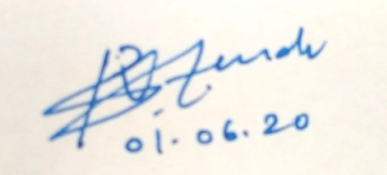

Dr. P.N.Shendge

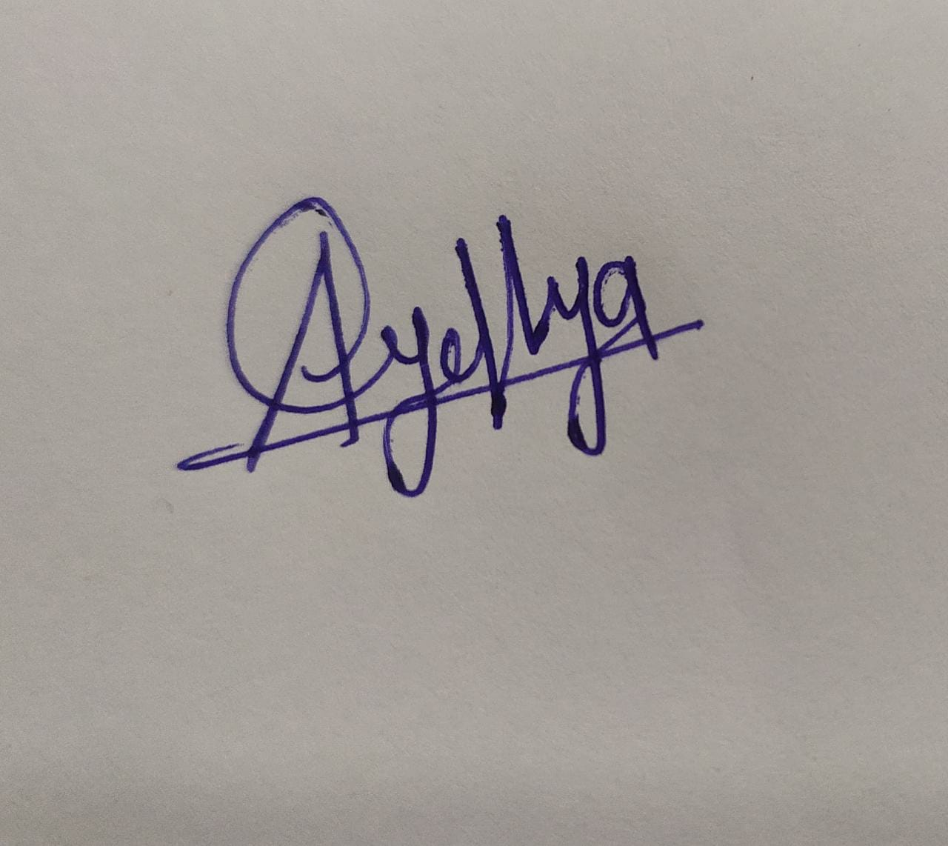

Logo

